Experiment 10: Execution of Linux Commands in Kali Linux
Aim
To execute and study the free, sort, and history commands in the Kali Linux operating system.
Algorithm
- Start Kali Linux and open the terminal.
- Execute the free command to display memory usage.
- Create a text file containing sample words.
- Execute the sort command to arrange the words alphabetically.
- Execute the history command to display previously executed commands.
- Observe and record the output of each command.
1. Free Command
Command:
free
Use of command: Displays the system's RAM and swap memory usage.
Sample output:
total used free
Mem: 4000000 1500000 1000000
Swap: 2000000 0 2000000
Note: Memory values shown above are examples.
To display memory in a human-readable format:
free -h
2. Sort Command
Command to create a file:
echo -e "Mango\nApple\nBanana" > file.txt
Command to sort the file:
sort file.txt
Output:
Apple
Banana
Mango
Use of command: Arranges lines of text in alphabetical or numerical order.
To sort in reverse order:
sort -r file.txt
Output:
Mango
Banana
Apple
3. History Command
Command:
history
Use of command: Displays the commands previously entered in the current shell session or saved in shell history.
Sample output:
1 pwd
2 ls
3 free
4 sort file.txt
5 history
To display the last five history entries:
history 5
Note: The actual output depends on the commands executed in your terminal.
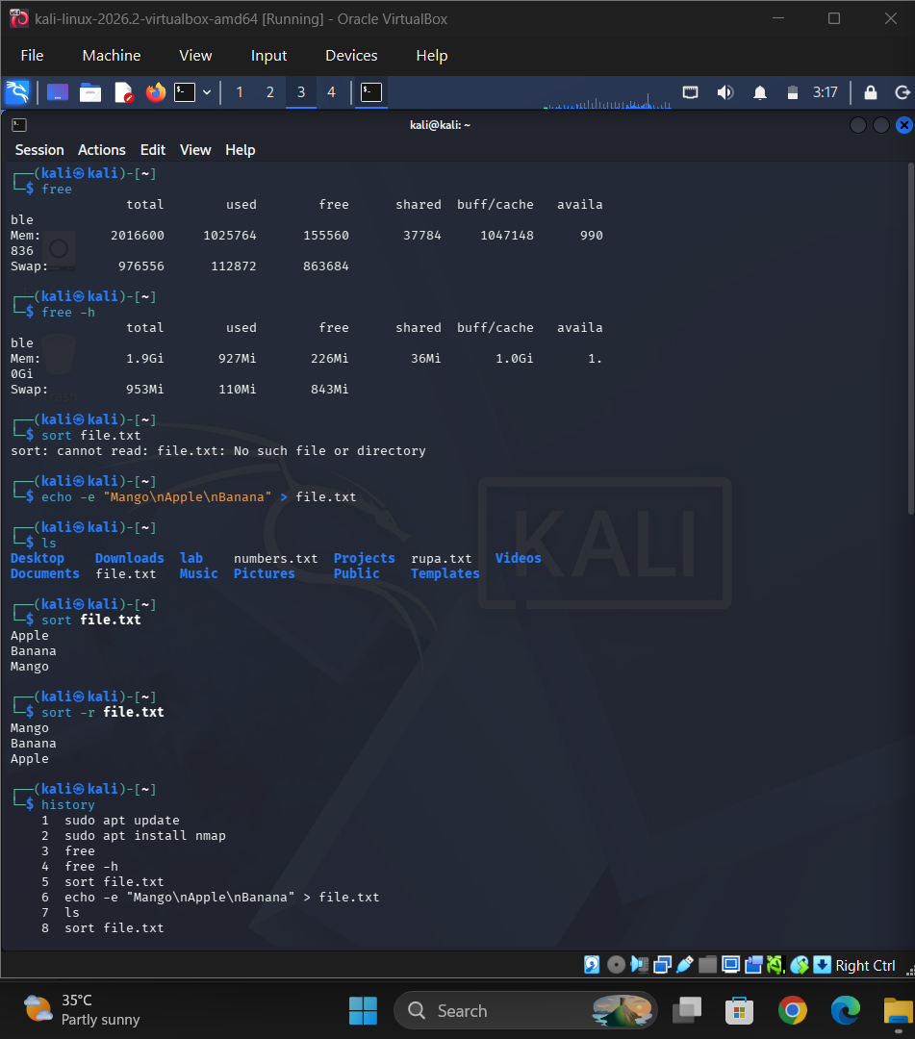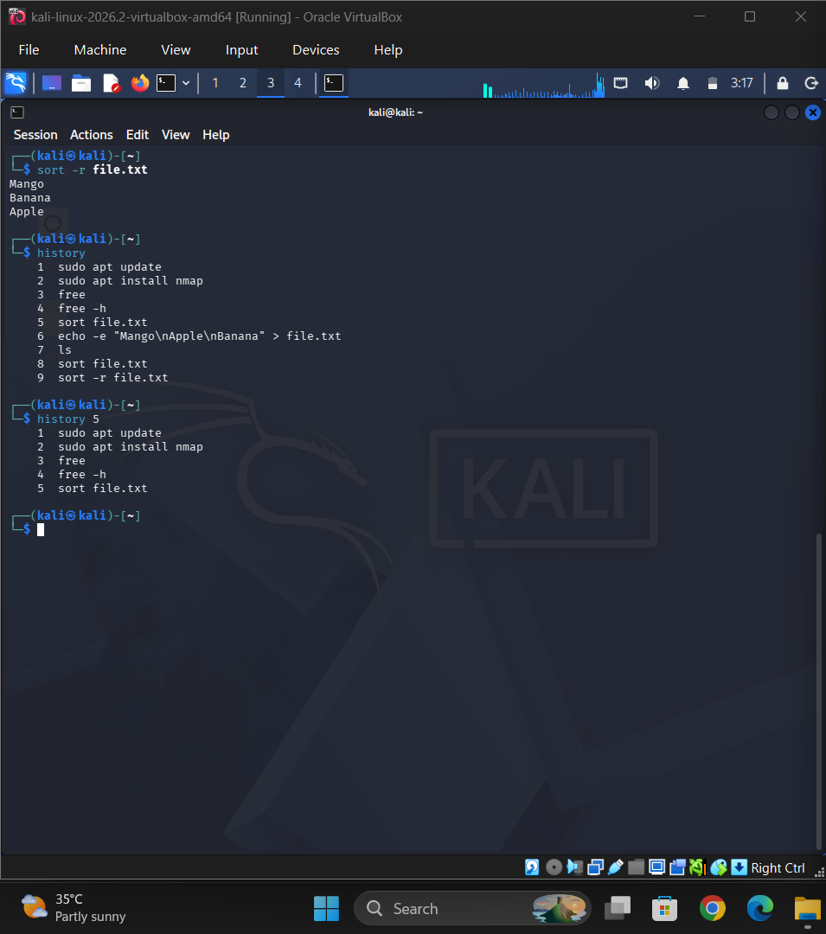
Result
The free command was used to display memory usage, the sort command was used to arrange text in alphabetical and reverse order, and the history command was used to display previously executed commands in Kali Linux.

